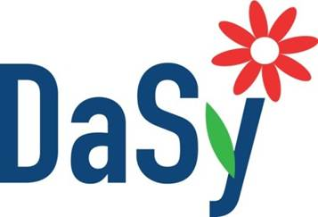
Stakeholder Engagement: Resource Review
Session 2: Serving as a Stakeholder for a Cross-Agency Data System Initiative

DESCRIPTION
This chart is designed to support a review of the resources provided. It is a way to organize information available in each resource for future reference and use.

RESOURCE | HELPFUL INFORMATION AVAILABLE IN THIS RESOURCE | PAGES TO REVIEW/REVISIT | POSSIBLE USES OF THIS INFORMATION
State Approaches to Engaging Local K12 Stakeholders
Engaging local K12 stakeholders is critical to ensuring the successful development of statewide longitudinal data systems (SLDS), as well as to improving utility and sustainability of those systems. Involving representatives from multiple agencies helps to identify, align, and leverage existing resources. This SLDS Spotlight resource discusses the strategies used and lessons learned by Virginia, Oregon, Iowa, and Washington, DC through efforts to engage their SLDS stakeholders.
Strategies for Engaging Early Learning Stakeholder
Developing a successful early childhood integrated data system (ECIDS) involves input and commitment from a diverse set of stakeholders. This publication explores several strategies for engaging stakeholders in decision-making processes, soliciting feedback, and maintaining productive relationships throughout the life of an ECIDS project. The strategies are illustrated by experiences and tips from Wisconsin and other states.
Stakeholder Engagement Toolkit: Traversing Stakeholder Land
This toolkit guides readers through a 6-step plan that builds towards effective stakeholder engagement. Along with the six steps, the toolkit supplies guiding questions, exercises, and tips to help users identify where they are in the stakeholder engagement process and where they need to go.

